Experiment 2: Wien Robinson’s Frequency Bridge

Name: Mansi Uniyal

Roll no.: 19EE10039

* Objective:

1. To calculate bridge component values in balance condition from signal source frequency.
2. To determine the response of the bridge with frequency variation, when the bridge is set for 1 kHz.

* In bridge balance condition:

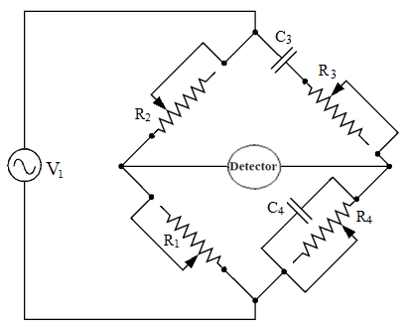

Derivation:

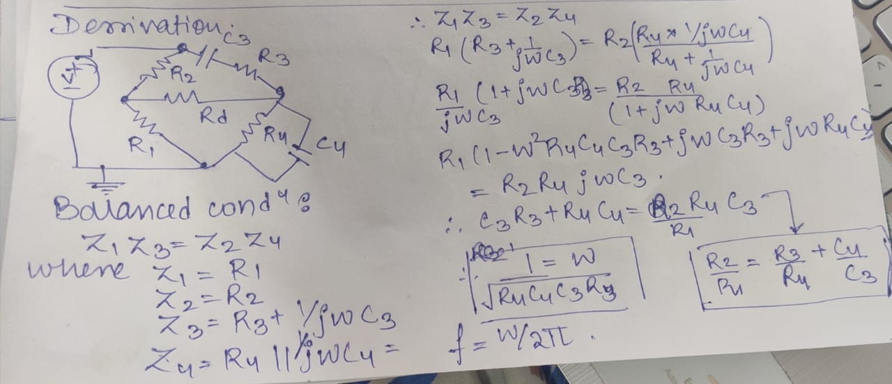

* Simulation Assignment:

1. Draw neatly the below bridge circuit in LTSpice. All the components should be chosen as ideal. In place of the detector use a resistance of 50 Ω. Attach the screen-shot of the schematic after entering your Name and Roll No as a text on it. Please see the reference example below.

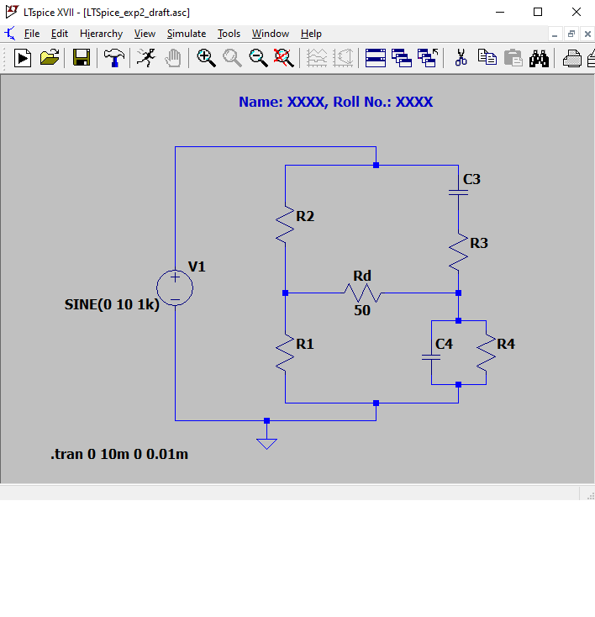

1. **CASE-I**: Keep *R2* = 6*R1* (say *R1* = 2 kΩ). Use a sinusoidal voltage source (V1) having a peak value of 10 V and a frequency of 1 kHz. At balance condition find out the values of *R3*, *R4*, C*3* and C*4*, assuming *R3C3* = *R4C4*. Select capacitors in the range of 0.1 µF to 10 µF and resistors in the range of 0.1 kΩ to 10 kΩ. Simulate and plot the current through the detector (i.e., the resistor of 50 Ω) in balance condition. Attach the screen shot of the plot.

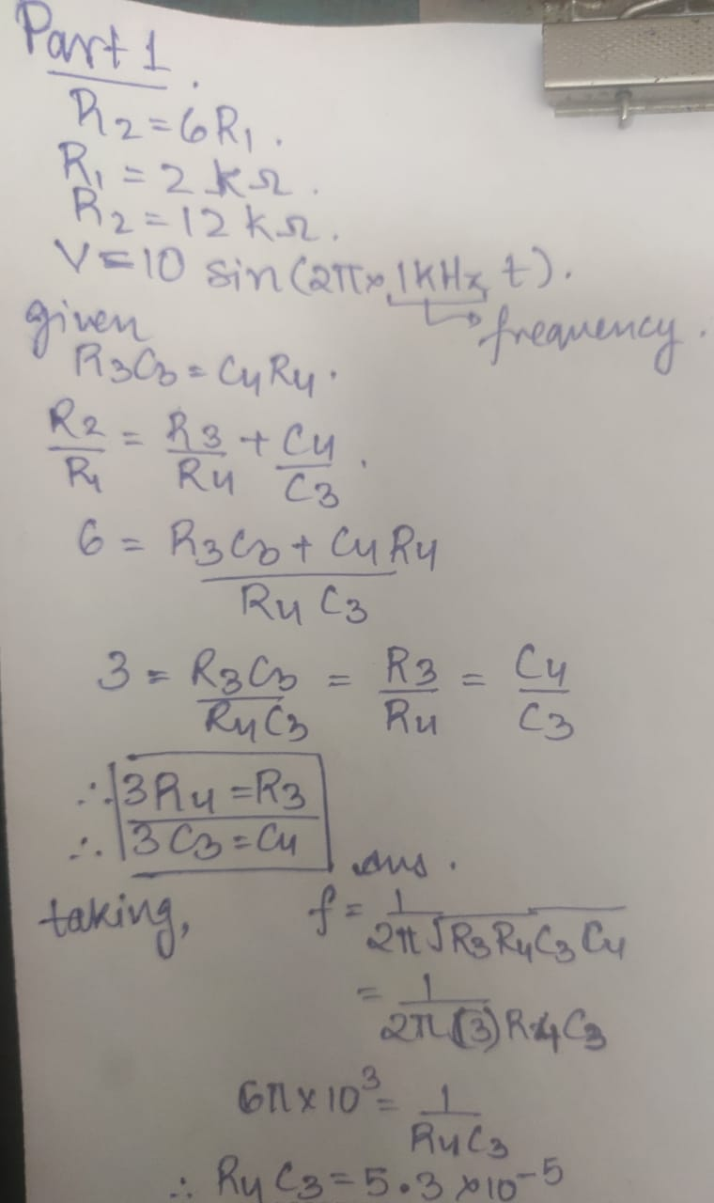

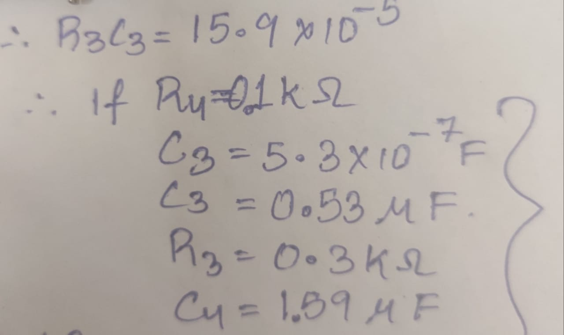

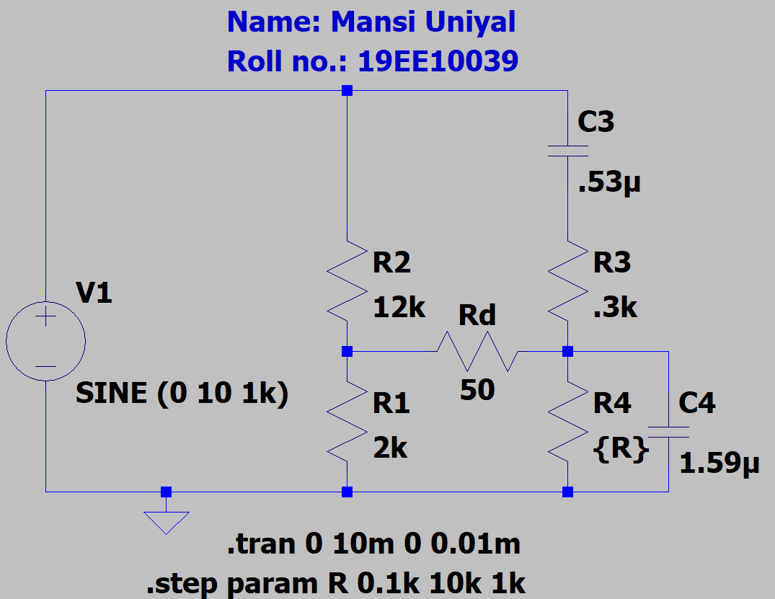

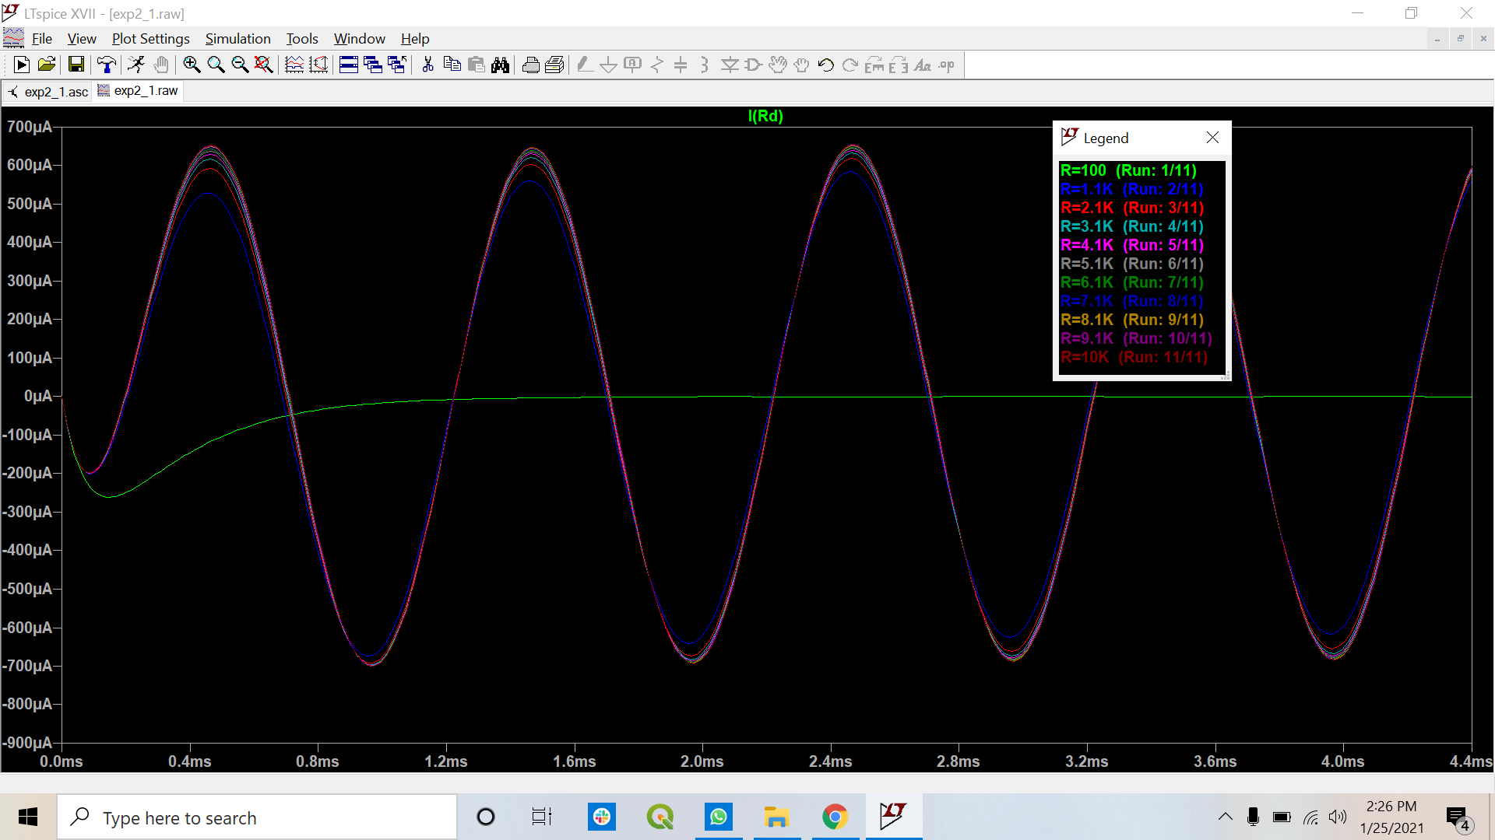

1. **CASE-II**: Repeat the simulation for *R2* = 2*R1* (say *R1* = 2 kΩ). Use a sinusoidal voltage source (V1) having a peak value of 10 V and a frequency of 1 kHz, and keep *C3 = C4* = 0.2 µF. At balance condition find out the values of *R3* and *R4* by adjusting the resistance *R3* and *R4* together such that they always have the same value. Plot the current through the detector (i.e., the resistor of 50 Ω) in balance condition, and attach the screen shot of the plot.

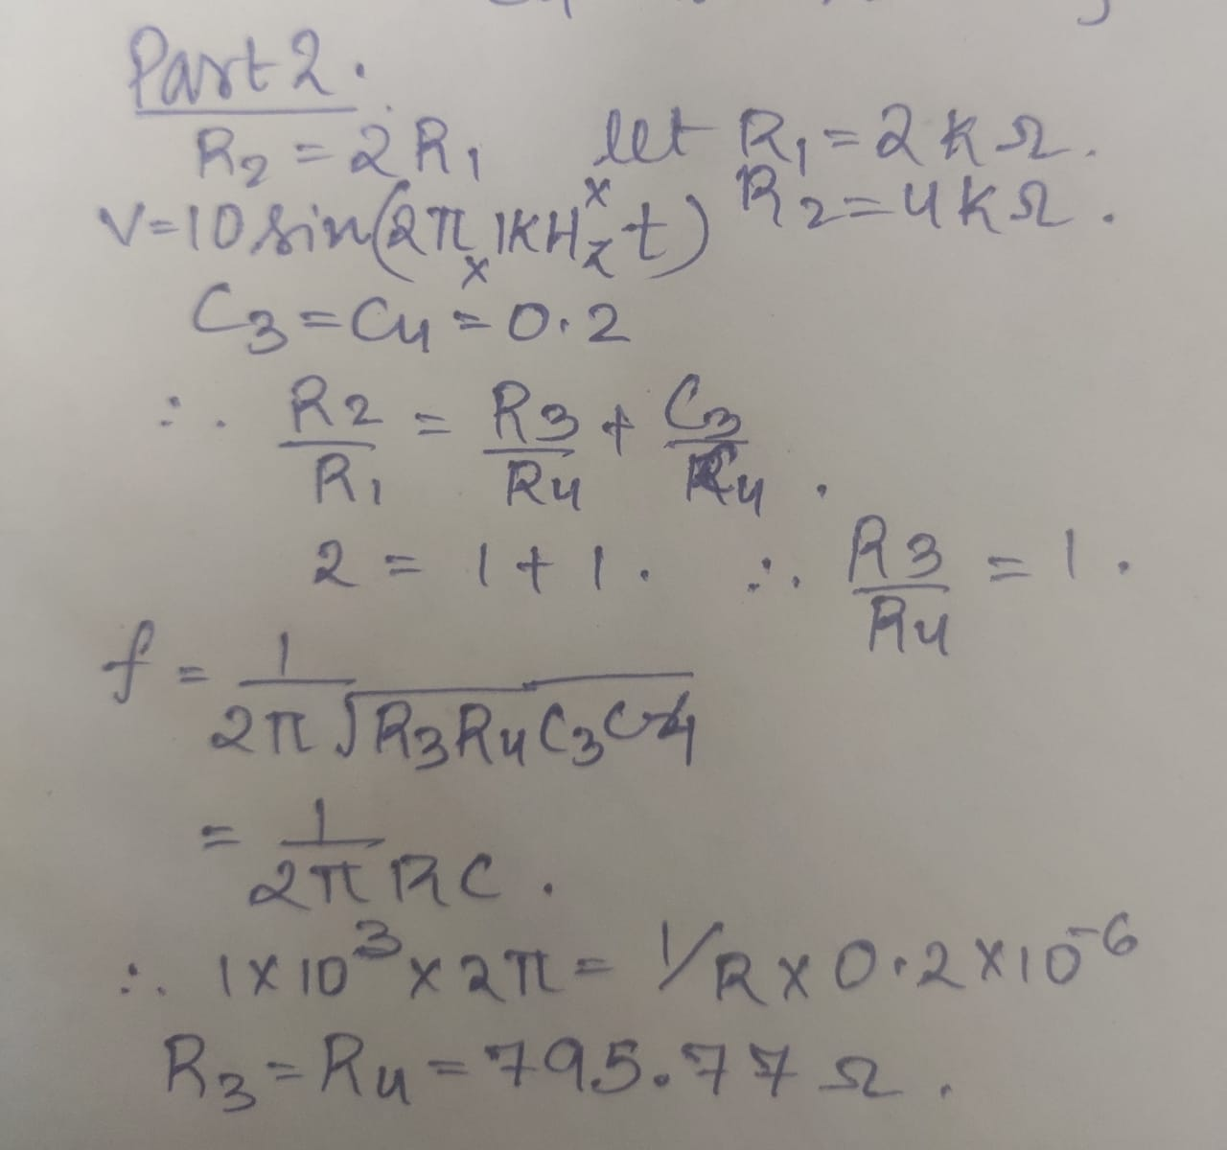

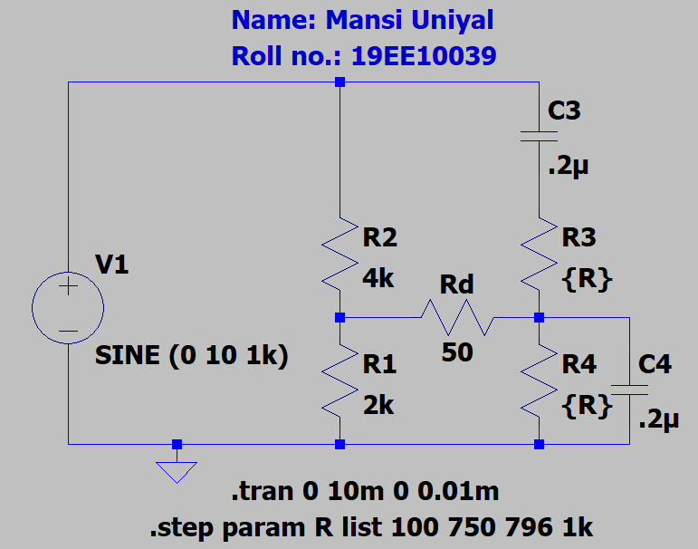

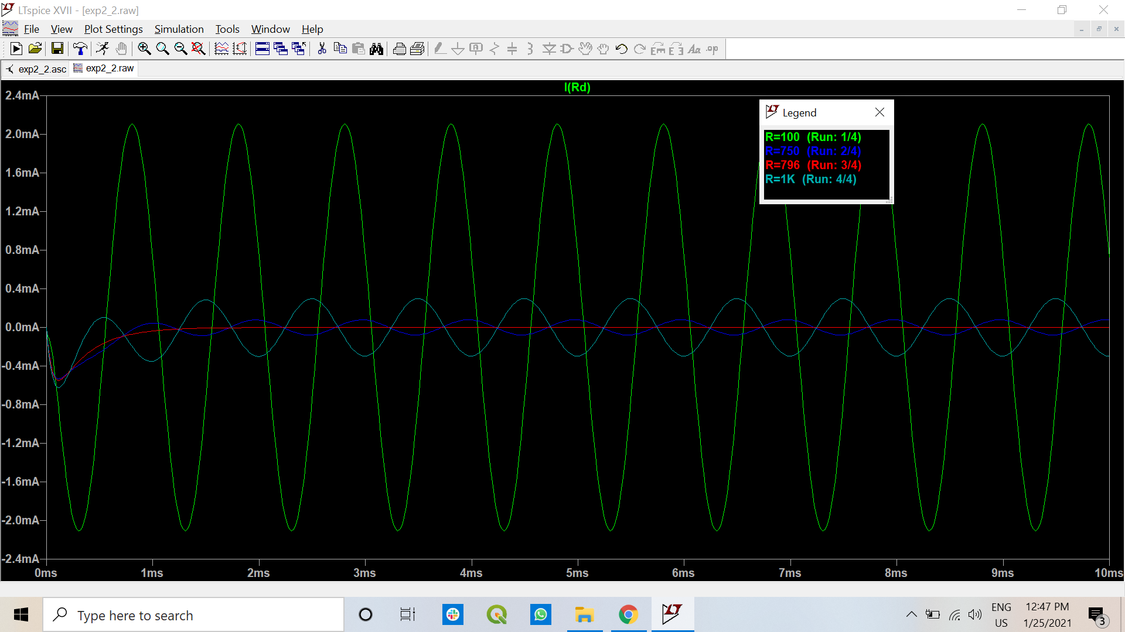

1. Repeat the simulation for CASE-II by varying the frequency of sinusoidal voltage source (V1) from 0.1 kHz to 10 kHz with a step of 0.1 kHz in the range of 0.1 kHz to 1 kHz and a step of 1 kHz in the range of 1 kHz to 10 kHz. Keep the peak value of V1 to 10 V. Plot the currents through the detector and attach the screen shots of the plots. Also plot a graph of the peak value of the detector current (in steady-state) vs. source frequency.

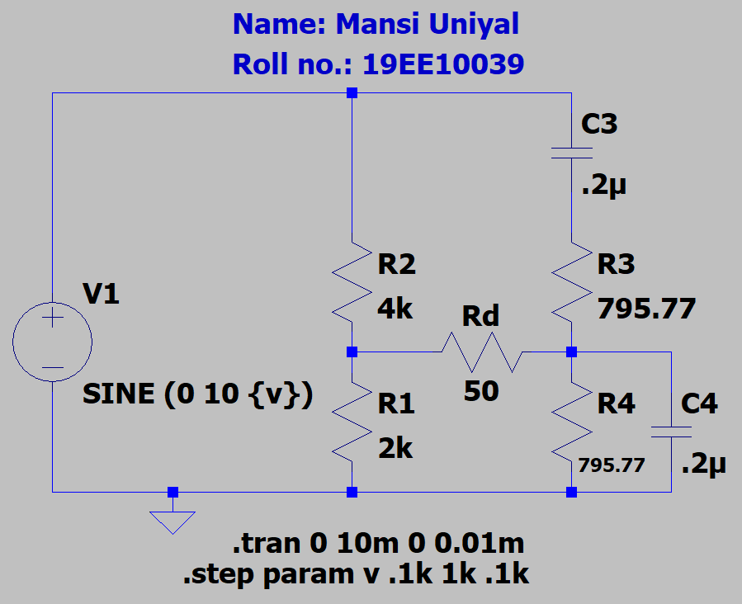

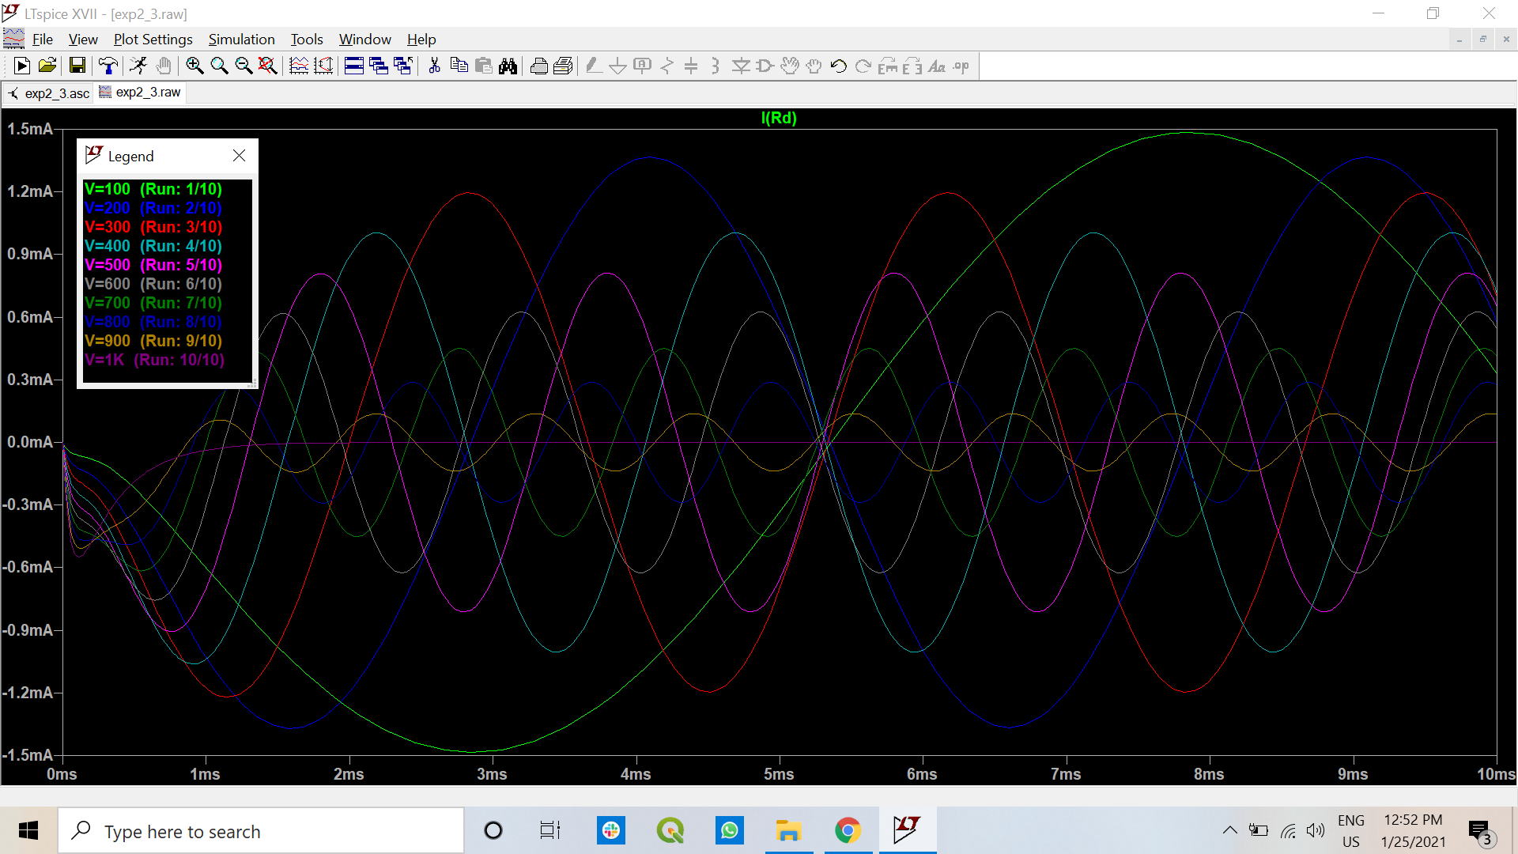

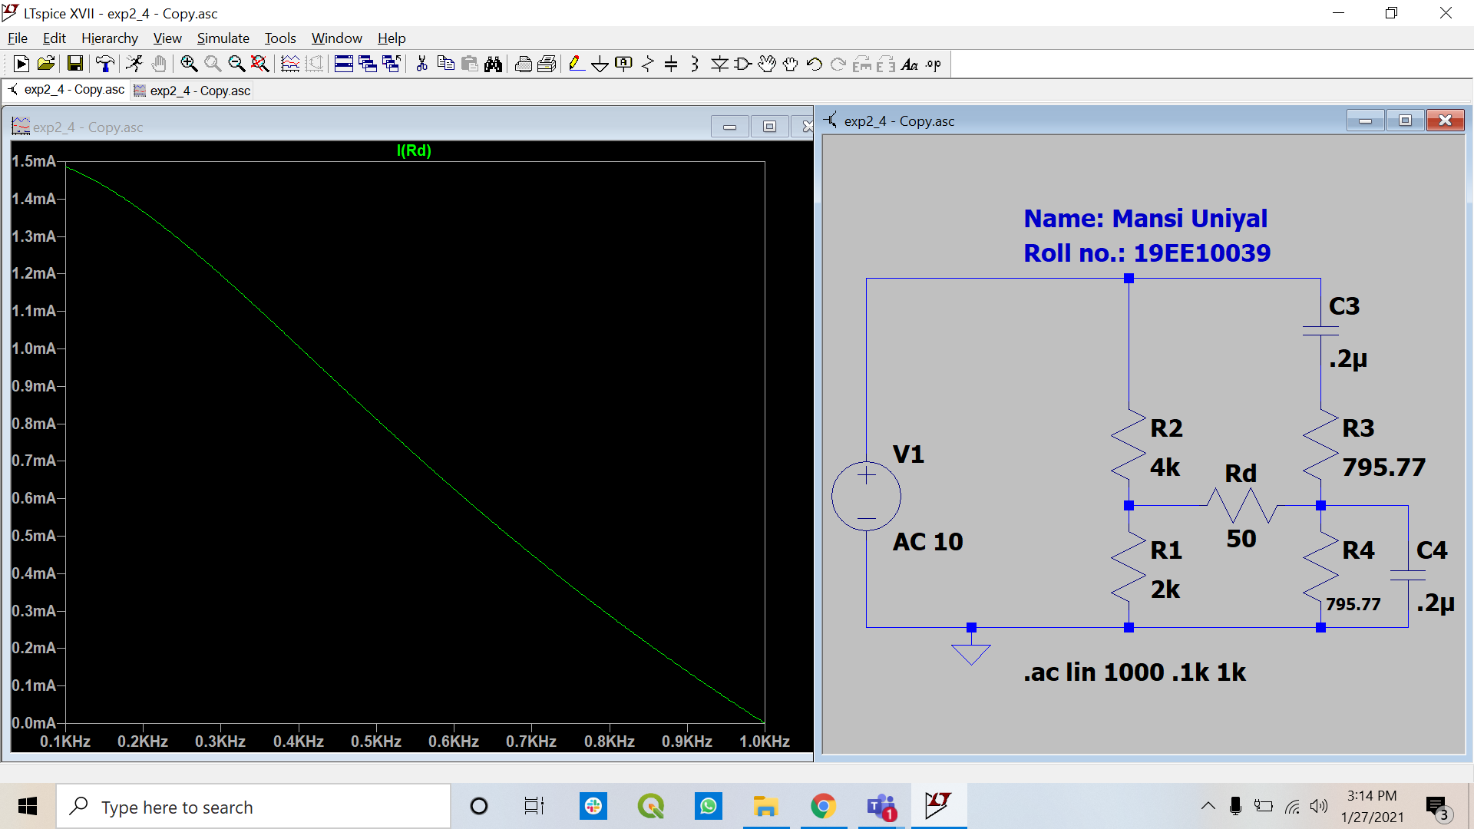

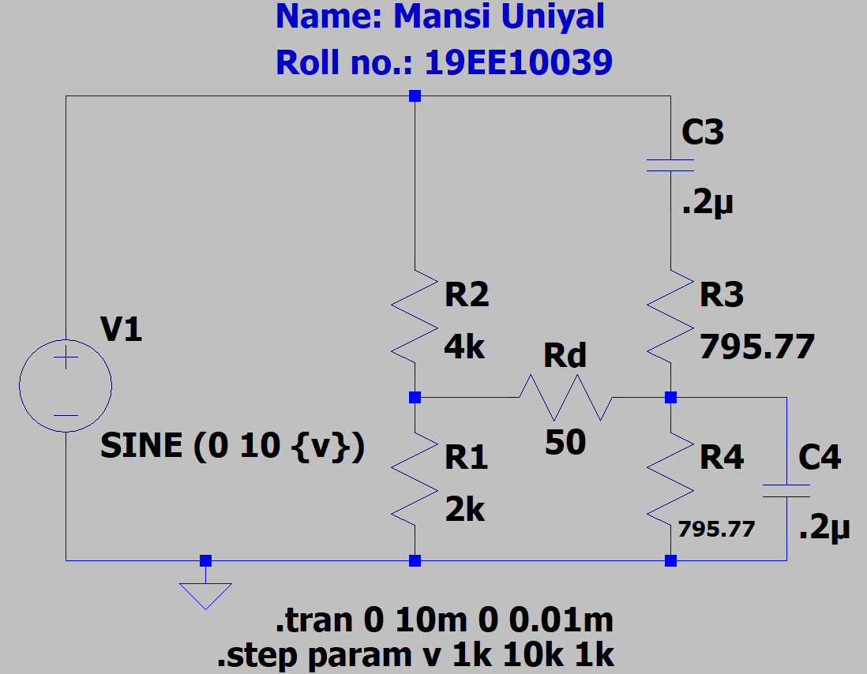

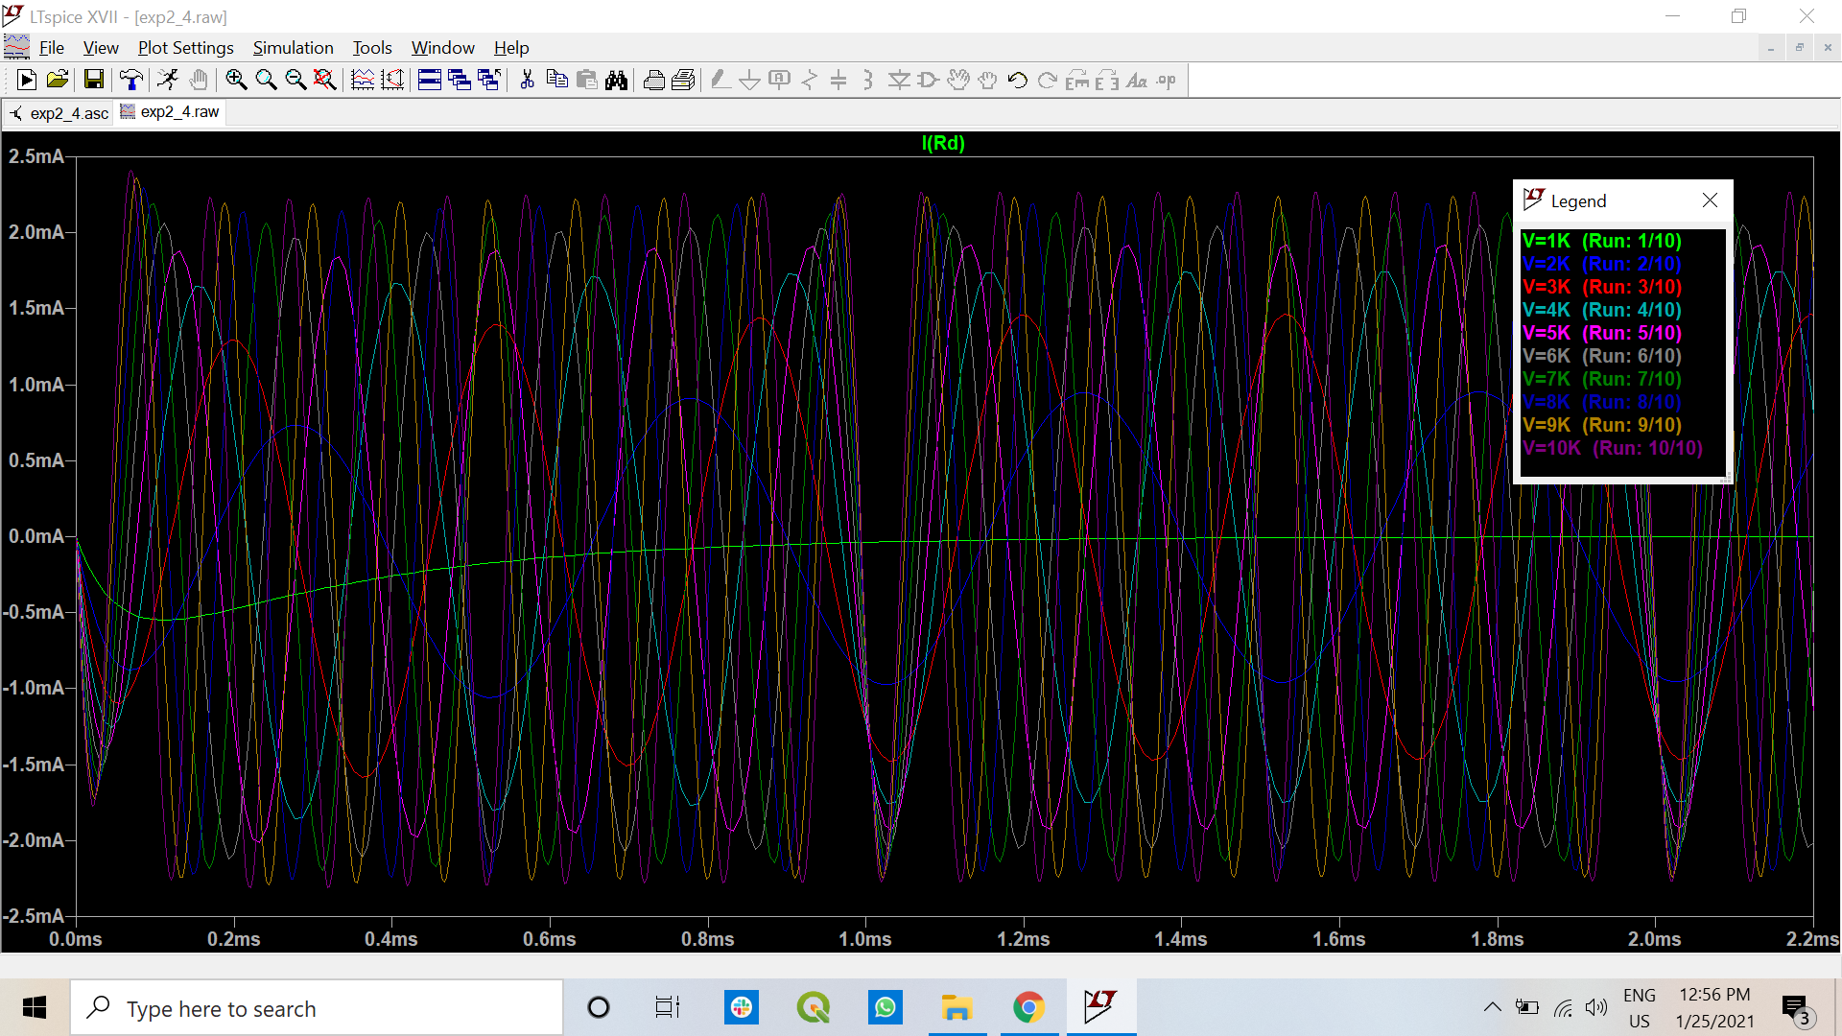

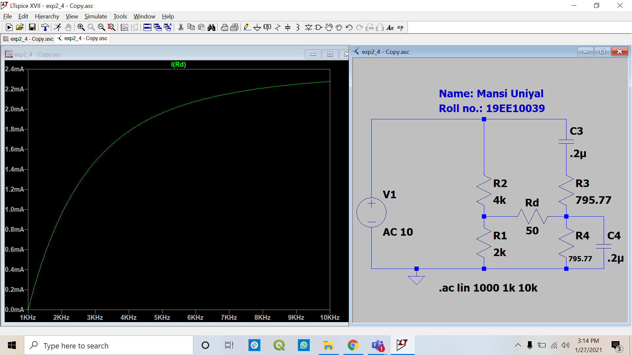

1. Repeat the simulation of CASE-II in balance condition for different values of *R1* (say, 10 values in the range of 0.5 kΩ to 10 kΩ). Plot the current through the detector and attach the screen shots of the plots.

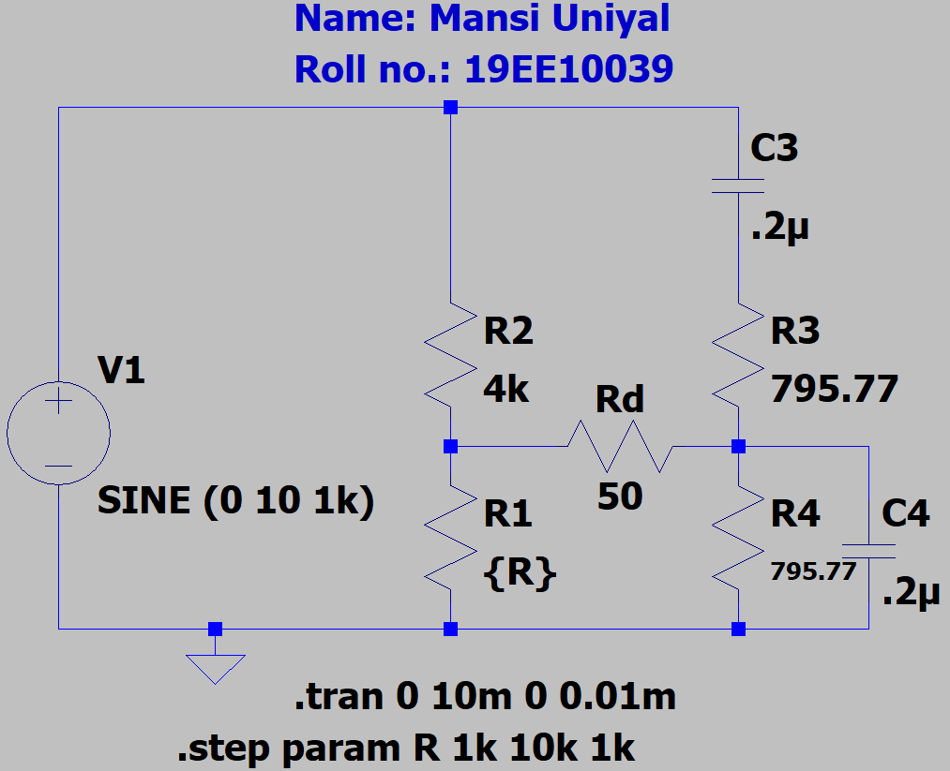

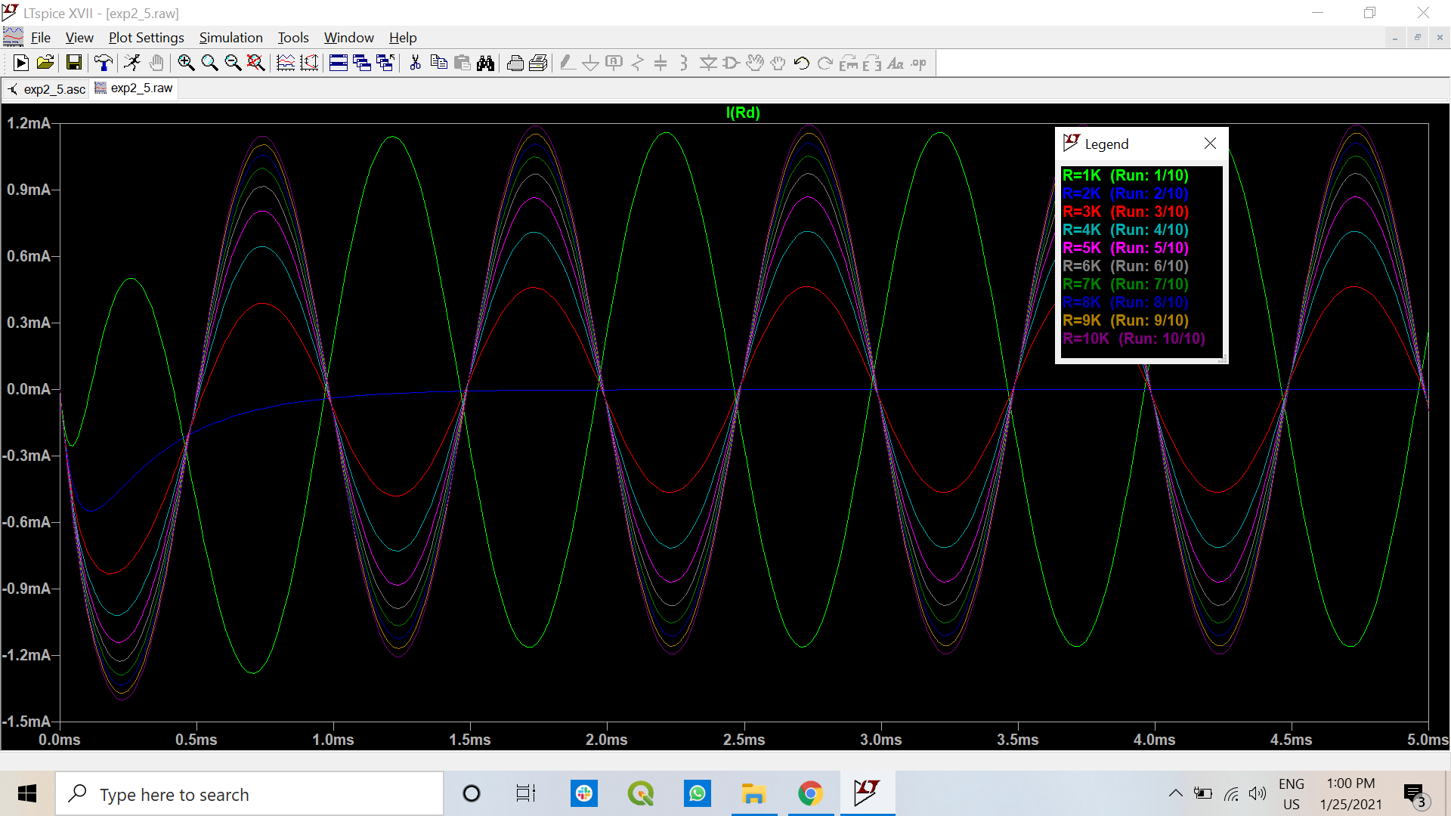

1. From the above (step e), choose the value of *R1* giving the maximum unbalanced current through the detector and with that value of *R1*, study the effect of variation of *R3* and *R4* on the unbalanced current.

**Maximum unbalanced current is 1.2 mA, by R1 as 10 kohm.**

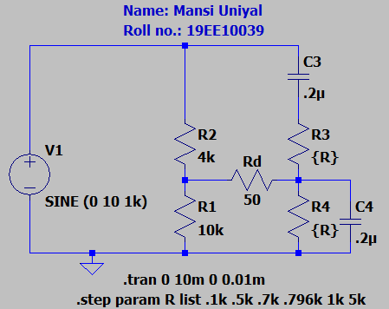

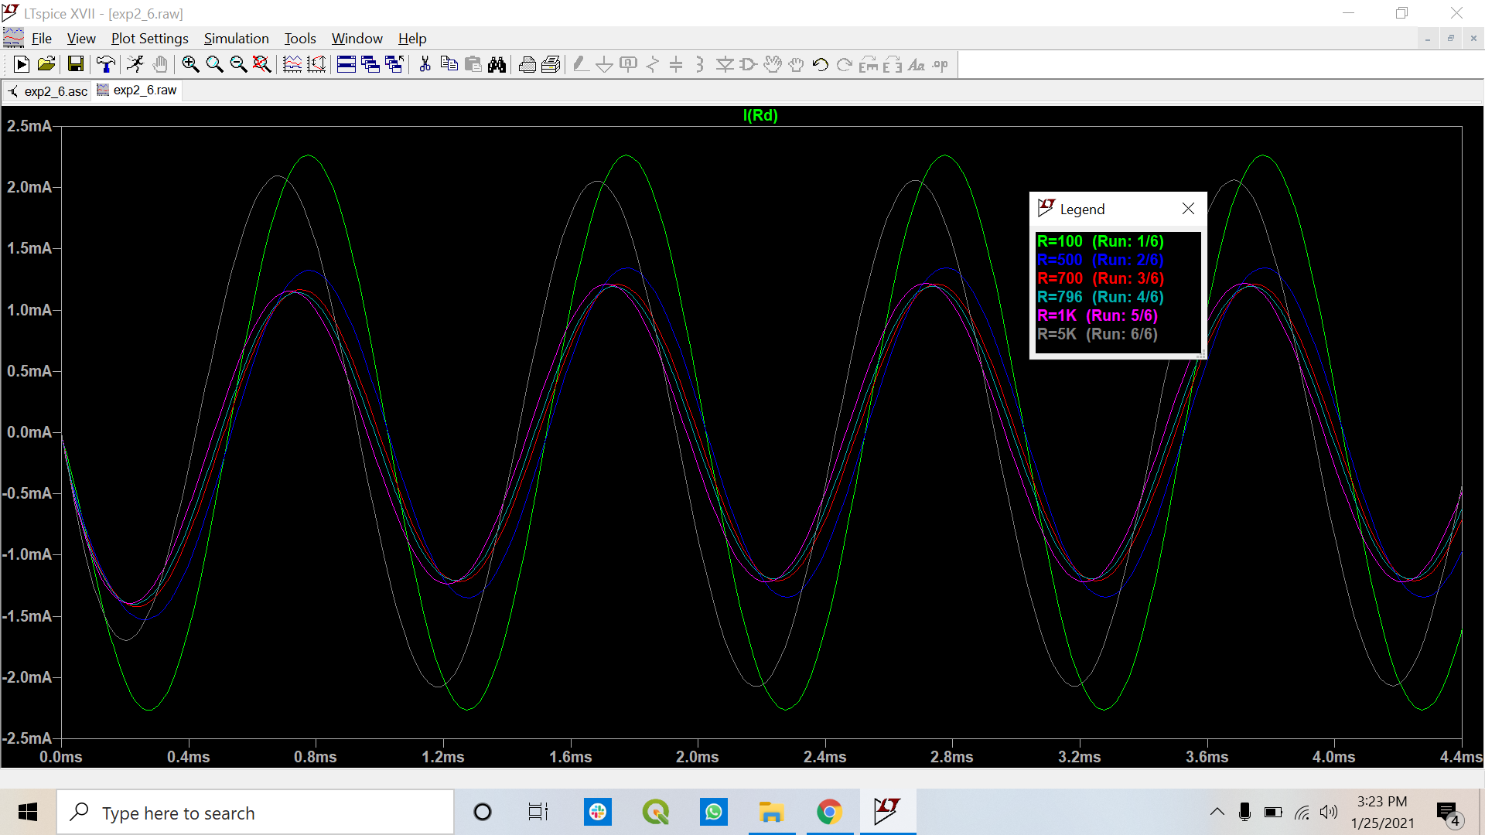

[**Note:** In the balanced condition peak current of the detector should be less than 100 nA]

* Points to be discussed in brief:

1. Compare merits and demerits of CASE-I and CASE-II

In CASE-I variation of detector current is more than in CASE-II.

Merit: Detector current in case 2 is in microAmpere while in case 1 it is in nanoAmpere.

Demerits: the bridge is highly frequency sensitive and also sensitive towards the values of resistances. Replacement of 2 resistors simultaneously in case 2 is tedious task.

1. Explain the reasons for the change of unbalance current for different *R1* values.

To measure the sensitivity of the bridge with respect to R1 value. The balanced point is disturbed hence there is a change of unbalance current for different R1 values.

1. How the unbalance current changes with the change of *R3* and *R4*.

There is a comparatively huge amount of deviation from the balanced condition by changing the values of R3 and R4 especially for the maximum and the minimum range. The unbalance current decreases till a balance point are achieved, then again starts increasing. In the present Case-II, the balance point is achieved when R=1kΩ

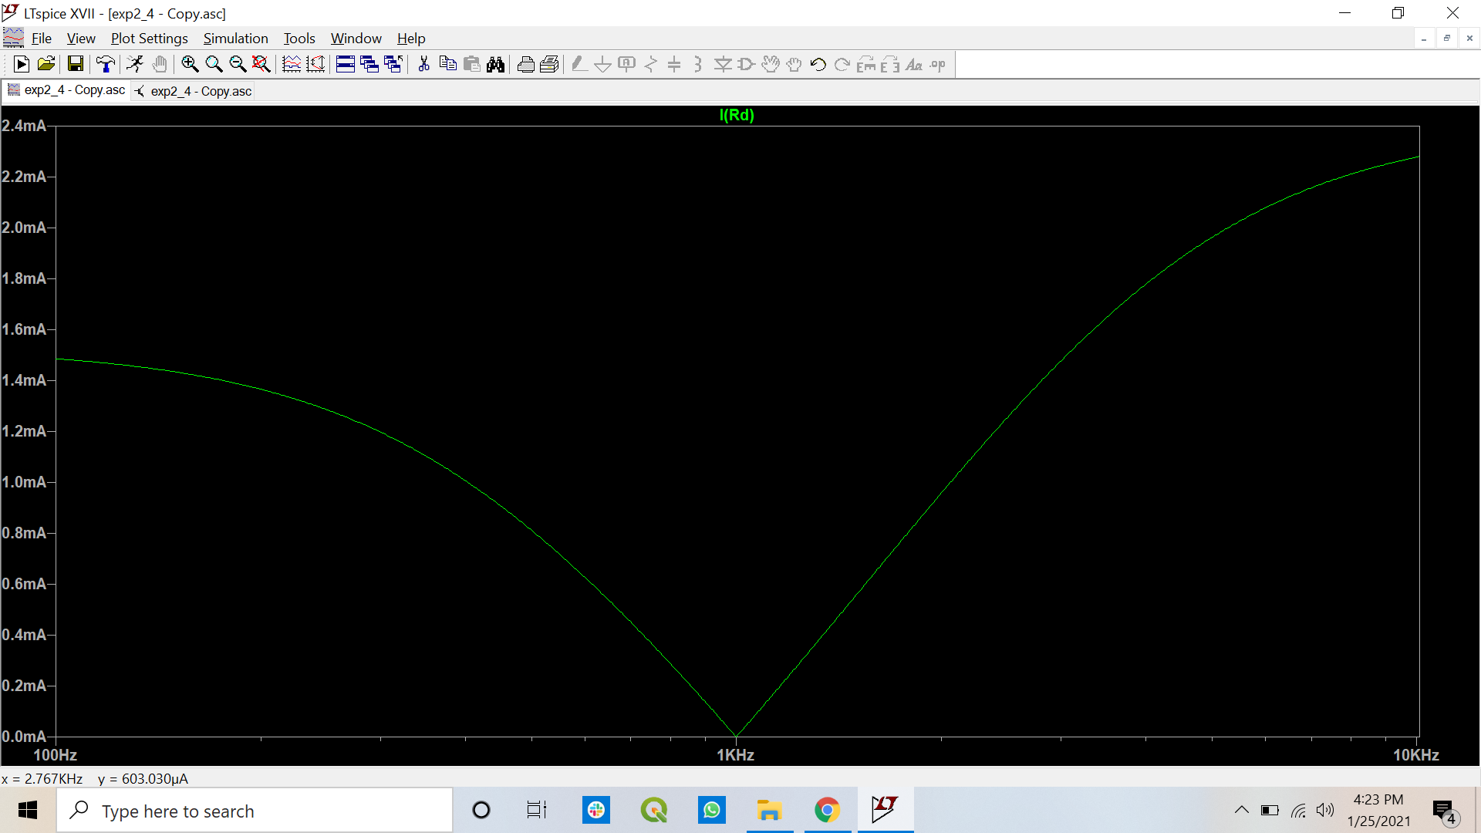

1. What happens if the source and detector are interchanged?

There will be no change in the circuit even if the source and detector are interchanged. The current plot and balanced condition will still remain the same. No change (Reciprocity Theorem)

1. What are the practical applications of this bridge?

The application of the bridge is used for audio frequency and capacitance measurement, the harmonic distortion analyser and in HF frequency oscillator.

1. Comment whether this bridge can be used for the measurement of capacitance.

Yes, the bridge can be used to measure capacitance. This can be done using a known environment of known resistances and voltage supply, by varying the resistance to obtain a balanced condition for the detector resistance. Using the balanced condition equations 1 and 2, we can find the capacitance value.